**VERIFICATION PROCEDURES**

**Version: 25.4.2016**

Prepared by: Vivi Sun

Approved by: Sergey Lykosov

Date approved:

Contents

1. Purpose 3

2. Scope 3

3. Terms and Definitions 3

**4.** **Verification** 4

4.1 Log in the CRM system 4

**4.2** **Get application from the working list/queue** 4

**4.3** **Make verification checks.** 4

**4.3.1.** **Check customer and urgent contacts historical profile** 4

**4.3.2.** **QuantGroup report analysis** 5

**4.3.3.** **JD/Taobao reports analysis** 6

**4.3.4.** **Search information about Customer employer, phone number and address in Baidu** 8

**4.3.5.** **Making calls** 10

**4.3.5.1.** **Call to company** 10

**4.3.5.2.** **Call to Customer** 12

**5.** **Make decision** 14

**6.** **Changing information in application.** 14

**7.** **Fraud Suspicion.** 14

**8.** **Exceptions** 14

# Purpose

Verification procedures includes

* conducting searches of the applicant in data services and other open sources (as Baidu);
* conducting phone verification calls.

|  |  |
| --- | --- |
| **Input** | **Output** |
| Assigned Application retrieved in Daily Productivity Tracker | Completed Verification for Disbursement Process: inputting values for verification variables |

# Scope

This document outlines the process of evaluating eligibility for loan approval for the Unsecured

MicroLoan product. Use the most current Verification Manual in identifying which parameters

and/or process are in effect during verification.

# Terms and Definitions

|  |  |
| --- | --- |
| **Term** | **Definitions** |
| Applicant | Customer applying for a loan |
| Parameter | Any of the criteria used to determine eligibility of applicant to be approved for a loan (or repeat loan). |
| CRM | Customer Relationship Management – the system for processing with Customer applications and Client agreements |
| Master file | Excel file that is used for processing Customer applications during launching period |
| PV | Phone Verificator |
| RR | Reject Reason |
| DPD | Day Past Due |

# **Verification**

## Log in the account to access Master file/CRM system

* Successfully login;
* Failed to login, check the user name and password, still failed, ask help from team leader or It helpdesk

## **Get application from the working list/queue**

* In tab “Phone Verificator single window” press button “Next application” to get application for processing;
* Work PV window is opened:

## **Make verification checks.**

The sequence PV checks:

* Search information in our company:
  + Customer history in our company (in Master file/CRM);
  + Customer urgent contact person history in our company (in Master file/CRM);
* Search information in data sources:
  + Belonging phone number to Customer (in Quant Group report);
  + Customer call history (in Quant Group report);
  + Customer address (JD/Taobao);
  + Customer phone number (JD/Taobao);
  + Customer in Tongdun black list
  + Customer in 91credit black list
* Search information about Customer employer in Baidu;
* Make call to detected company phone numbers;
* Make call to company phone number in application (if needed);
* Make call to Customer.

## **Check customer and urgent contacts historical profile**

Customer history in our company need to be checked in CRM/Master file (for searching use customer ID), because it is allowed only one active/processing Customer application in one time and only one active loan agreement:

* Customer has previous application:
  + If YES: check status of previous application:
    - Final approve – decline by current application (RR → repeat application); *NB: application was already approved but not disbursed*
    - Final decline – if previous application was decline during past 30 days, ***decline current application*** if not, ***continue processing current application***;
    - In process – decline by current application (RR → repeat application);
  + If NO - continue processing current application.
* Customer has payment history:
  + If YES: check loan status:
    - Active loan → decline by current application (RR → has active loan);
    - Closed loan with DPD > 7 → decline by current application (RR → bad credit history);
    - Closed loan with DPD <= 7 → continue processing current application;
  + If NO - continue processing current application.

Urgent contact person payment history in our company need to be checked in CRM/Master file (for searching use urgent contact phone number):

* Urgent contact person has payment history:
  + If YES: check loan status:
    - Active loan → decline by current application (RR → Urgent contact person has active loan);
    - Closed loan with DPD > 7 → decline by current application (RR → Urgent contact person has bad credit history);
    - Closed loan with DPD <= 7 → continue processing current application;
  + If NO - continue processing current application.

## **QuantGroup report analysis**

In QuantGroup report need to be checked:

* Belonging phone number to Customer (search by Customer ID number and phone number in QuantGroup):
* If Customer ID is deferent in application and report, but phone number is the same → decline by current application (RR → Belongs to 3-d party);
* If Customer ID is the same, but phone numbers are deferent → decline by current application (RR → Belongs to 3-d party);
* If Customer ID and phone number are the same → continue processing current application (put result in Master file - Belongs to customer).

|  |  |  |
| --- | --- | --- |
| University | Department | Type of University |
| Education system | Time start | Time finished |
| Working place : | | |
| Cellphone : | | |
| Emai: | | |

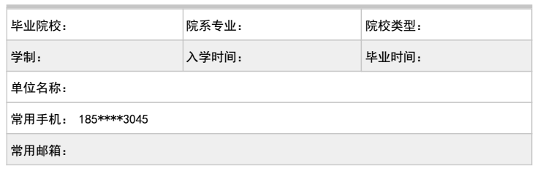

* Customer call history (check top 10 contacts):
  + If top 10 contacts **were made earlier than 3 months ago** → continue processing current application (put result in Master file - Earlier than 3 months);
* If **no calls earlier than 3 months** in history → decline by current application (RR → Later than 3 months), because too short phone call history;
  + If **top 10 contacts were made within last 7 days** → continue processing current application (put result in Master file - later than 7 days);
  + If **no call during last 7 days** → decline by current application (RR → Earlier than 7 days), because Customer didn’t use his phone last 7 days;

|  |  |  |  |  |  |  |  |
| --- | --- | --- | --- | --- | --- | --- | --- |
| Basic contact person list | | | | | | | |
| Number | City | Call times | Time(sec) | Dialing | incoming call | First call of 6months | last call |

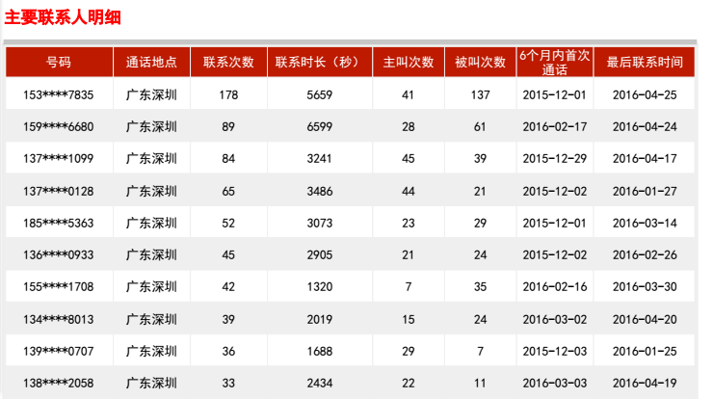

* Customer address in shipping statistic (search by Customer address):
  + If Customer address is found in JD/Taobao reports → continue processing current application (put result in Master file - Found);
  + If Customer address doesn’t appear in shipping statistic → decline by current application (RR → Not found).

Delivery Address information

|  |  |  |  |  |  |  |
| --- | --- | --- | --- | --- | --- | --- |
| Number | Address | Consignee | Tel of Consignee | Amount | First delivery time | Last delivery time |

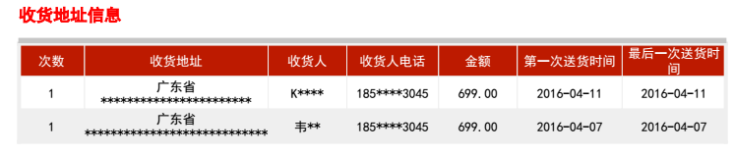

* Customer phone number in shipping statistic (search by Customer phone number):
  + If Customer phone number is found in JD/Taobao reports → continue processing current application (put result in Master file – Customer phone number is in history);
  + If Customer phone number doesn’t appear in shipping statistic → decline by current application (RR → Customer phone number is not in history).

|  |  |  |  |  |  |  |
| --- | --- | --- | --- | --- | --- | --- |
| Time | Status | Goods | Amount | Type of Payment | consignee | Tel |

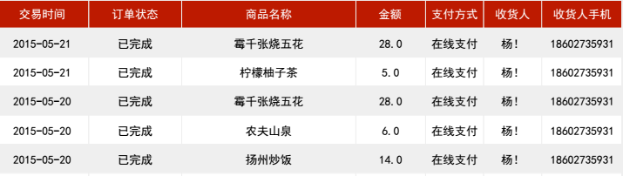

* Customer calls to urgent contact person (search in top 10 customer’s contacts urgent contact’s number):
  + If Customer calls to urgent person in application is in list of top 10 contacts → continue processing current application (put result in Master file – Is in top 10);
  + If Customer calls to urgent person in application is NOT in list of top 10 contacts → decline by current application (RR → Not in top 10).

|  |  |  |  |  |  |  |  |
| --- | --- | --- | --- | --- | --- | --- | --- |
| Basic contact person list | | | | | | | |
| Number | City | Call times | Time(sec) | Dialing | incoming call | First call of 6months | last call |



## **Search information about Customer employer, phone number and address in Baidu**

Check information about company (company name, phone number and address) on @Baidu website to find out negative information OR confirm information in application AND try to detect additional phone company numbers, because of this depends scripts with company and Customer.

Search information about company by company name and company phone number:

* If company number belongs to encashment agency → decline by current application (RR → Belongs to encashment agency);
* If company number belong to different company → continue processing current application (put result in Master file - Belongs to different company), but USE ADDITIONAL QUESTIONS during calls to company and Customer;
* If company number is not found in Baidu → continue processing current application (put result in Master file – Not found), but USE ADDITIONAL QUESTIONS during calls to company and Customer;
* If company phone number confirms in Baidu to the same company → continue processing current application (put result in Master file – Belongs to the company name) and USE SHORT script with company.

Search information about Customer phone number:

* If Customer number belongs to encashment agency → decline by current application (RR → Belongs to encashment agency);
* If Customer number is not found in Baidu → continue processing current application (put result in Master file – Not found)

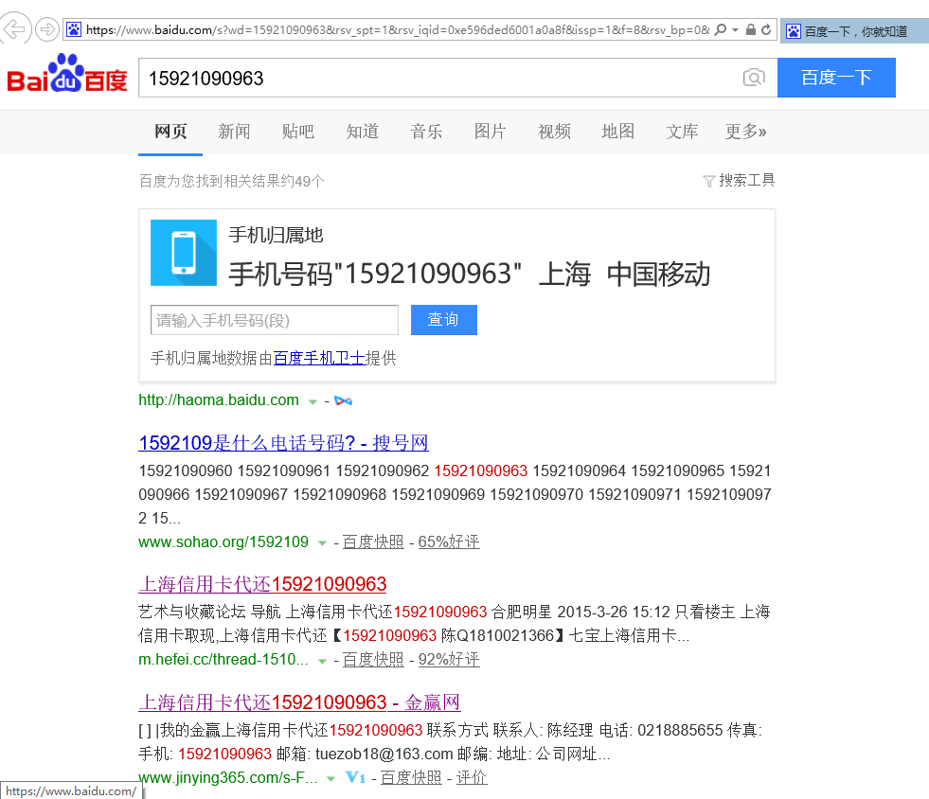

Phone # belongs to encashment agency

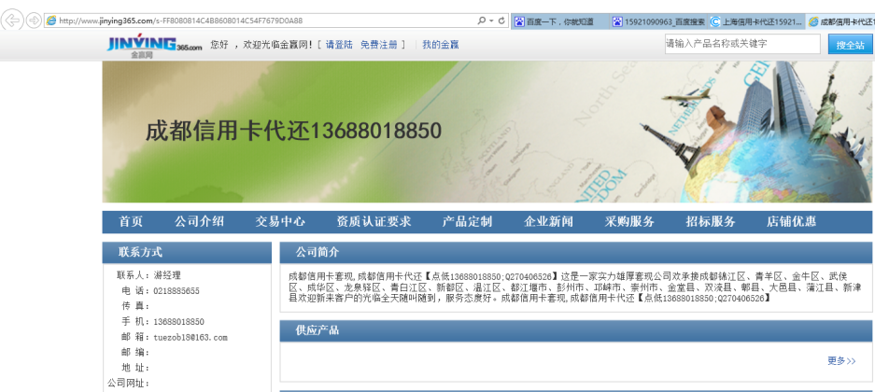

Website with detailed information of encashment agency

Search information about company address to get information that can be use while conversation with company representative and Customer (nearby the station/restaurant/signs/etc.):

* If company address is confirmed → continue processing current application (put result in Master file – Confirmed);
* If company cannot be found by address → continue processing current application (put result in Master file – Not confirmed) and USE ADDITIONAL QUEATIONS during calls to company and Customer.

Search information about Customer living address to get information that can be use while conversation with Customer (nearby the station/restaurant/signs/etc.):

* If living address is confirmed → continue processing current application (put result in Master file – Confirmed);
* If living address cannot be found in Baidu → continue processing current application (put result in Master file – Not confirmed) and USE ADDITIONAL QUEATIONS during calls to Customer.

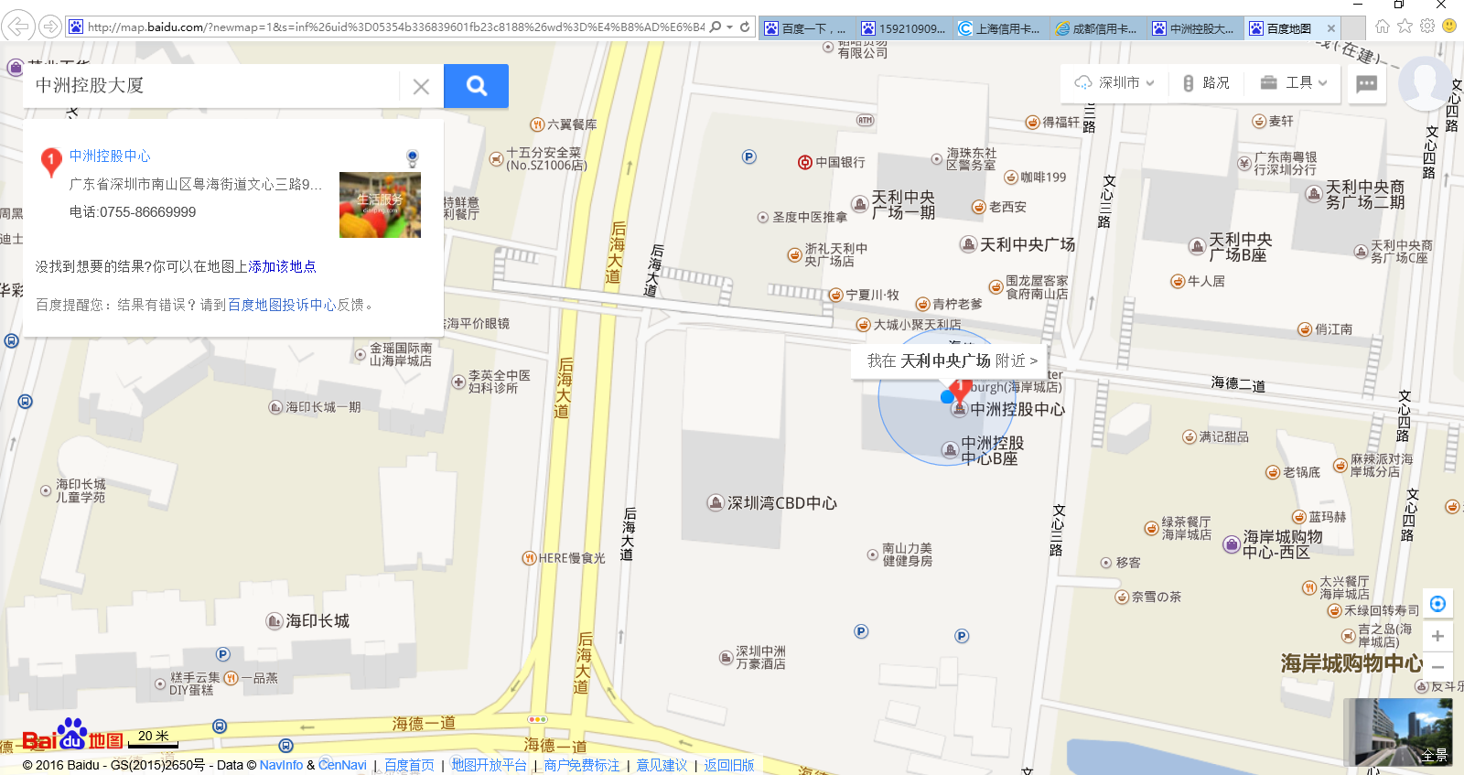

## **Making calls**

## **Call to company**

The aim of calling to company is to confirm that Customer is known in company and try to get employment information.

Call script to company depends on internet check result.

**Calling rules:**

* Check information in application (company name, Customer employment data) and search information about the company before calling to company;
* Make calls to company by detected in the Internet phone numbers firstly (if any);
* Ask additional cross-check questions (2-3) if call by company phone provided by Customer and not confirmed in Internet;
* In case nobody picks up the phone make attempts according following rule: need to call to company/office phone not less than 3 times during working hours in different time periods during 2 working days:
  + 9 a.m. – 12 a.m.;
  + 12 a.m. – 3 p.m.;
  + 3 p.m. – 6 p.m.;
* Proceed verification next phone number from the application if from the 1st attempt nobody answers (means call results = “don’t pick up phone” or “refuse to give information”).
* Use this guidelines to detect fraud:



After conversation with the company’s representative put the result of the phone call

|  |  |  |
| --- | --- | --- |
| **Work phone results** | | |
| Result | Logic | Description |
| Not called (default value) | New check is required |  |
| Nobody has answered the call (after 4 tries during 2 working days). | Decline | PHV call to company by work phone in application and detected phone numbers (if any), but nobody has answered in office during after not less 4 tries (in a day) during 2 working days |
| Denies to provide information | Decline | PHV contact with company representative by work phone in application and detected phone numbers (if any), but he denies to provide information about Customer |
| Customer employment confirm | Continue | PHV contact with company representative by work phone in application and detected phone numbers (if any), and he confirm Customer employment |
| Out of coverage Area (Office address) | Decline | Customer is not working within the range |
| Occupation is not complying with Credit Policy | Decline | Occupation: policy/military, self-employed, business owner, unemployed, student, housewife |
| Phone number is not registered/not available/turn off | Decline | Work phone number is not registered/not available/turn off, and no other company phone is detected. |
| Company is inactive/ no longer operated | Decline | PHV detected that company is inactive/ no longer operated |
| Company phone in application doesn't belongs to Customer employer | Decline | PHV call to company phone in application, but Customer’s company is not known, and no other company phone is detected |
| Customer is/will be resigned | Decline | PHV contacts with company representative by work phone in application or detected phone numbers (if any), and get information that Customer is/ or will be resigned/retired |
| Customer unknown at office/never work at company | Decline | PHV contacts with company representative by work phone in application or detected phone numbers (if any), but Customer is unknown at office/never work at company |
| Fake company or receiver is directed to answer PHV by third party | Decline | PHV contacts with company representative by work phone in application and detected fraud sign (“company representative” confirms Customer employment, but by detected real company phone number Customer is unknown at office/never work at company or receiver fails to answer to additional question or his answers are not matched with detected information: about company address, company occupation, Customer’s responsibilities, customer’s work days and so on) |
| Company’s number belongs to encashment agency | Decline |  |

## **Call to Customer**

The aim to call to Customer is to confirm possibility to contact with Customer and his willingness to payout.

Call to the customer’s phone number using the script ‘Customer call script’ and fill in the results (see the ‘Customer call result’ table)

**Calling rules:**

* + - * Check information in application, make checks by data reports and in Baidu before calling to Customer;
      * Ask additional cross-check questions (2-3) if Customer living address is not confirmed in Baidu;
      * In case nobody picks up the phone make attempts according following rule: need to call to Customer phone not less than 4 times during the day in different time periods during 2 days:
      * 8a.m. – 10 a.m.;
      * 10 a.m. – 2 p.m.;
      * 2 p.m. – 6p.m.;
      * 6 p.m. – 8 p.m.
      * For cross checking questions, refer to the scripts manual, ask 3 or more cross questions
      * set up the results, for comparison customer answers vs application form subjected info and other information detected during company verification and anti-fraud reports;

NOTE. To be sure in Customer willingness to payout and reliability, it is very important to ask smart questions and hear Customer reaction and compare his answers with information detected in previous checke:

* compare Customer answers with information in application and information detected in Internet, during company verification and in anti-fraud reports;
* hear Customer reaction:
* if Customer is nervous;
* if Customer need time to imagine answers;
* if Customer answers directly on application form questions and try to avoid answers on additional questions.

After phone conversation with the customer check the result of the phone call

|  |  |  |
| --- | --- | --- |
| **Customer call result** | | |
| Result | Logic | Description |
| Not called (default value) | New check is required |  |
| Customer is successfully contacted, there are no obvious signs of fraud | Continue | PHV call to Customer and he clearly confirm information. |
| Customer doesn't pick up phone/is busy not available to have a conversation with PHV (after 4 tries during 2 days) | Decline | PHV call to Customer number, but nobody answers during 2 days. Contact person confirm Customer phone number. |
| Not registered/not available/turn off | Decline | Customer phone number is not registered/not available/turn off |
| Customer doesn’t have need anymore | Decline | PHV call to Customer, but he insists that no need loan any more.  PHV should ask the reason (obligatory). |
| The mobile phone in application belongs third person, not Customer | Decline | PHV call to Customer phone number, but answer third person, who doesn’t know Customer.  PHV need to confirm Customer phone number by contact person. |
| Occupation is not complying Credit Policy | Decline | Customer occupation isn’t complying with Credit Policy: policy/military, self-employed, business owner |
| Customer is jobless/student/housewife/retired | Decline | Customer is unemployed, student, housewife |
| Customer age is not qualified | Decline | Customer is under22 or over 50aged. |
| Customer working place is out of service of DoctorCash | Decline | Customer is not working within serviced cities {need to create the list of cities} |
| Reject as request from Risk | Decline | Reject as request from Risk |
| Living address is in blacklist | Decline | Living address is in blacklist |
| Customer had problems with loan repayments earlier | Decline | Customer had problems with loan repayments earlier |
| Applicant applies loan for another person and isn't responsible to the loan | Decline | Applicant applies loan for another person and isn't responsible to the loan |
| Customer is directed to answer PHV by third party | Decline | Customer is directed to answer PHV by third party |
| Customer can't confirm employment information (fails to describe the current job/contrast with the information provided by contact person from company) | Decline | Customer’s answers are different compare to answers from company’s representative |
| Customer can't confirm current living address | Decline | Customer’s answers are different compare to Baidu maps information |
| Applicant can’t provide contact of reference (spouse/ siblings/ parents) | Decline | According to the Credit policy at least 1 contact should belong to the close relatives |
| Third person use real Customer data | Decline | Customer says that he doesn’t apply to company. |
| Negative information (detoxification/rehabilitation center/loan for gambling/illegal income) | Decline | Customer says that he had problem with alcohol/drugs addicted/gambling or has illegal income/etc. |
| Internal Fraud (Customer doesn't know about product/etc.) | Decline |  |
| Customer doesn't match with profile in social network AND fails identity cross-check | Decline | Customer answers don't match with profile in social network AND fails identity cross-check |
| Customer has active loan | Decline | Customer has active loan in company |
| In QuantGroup report Customer phone number belongs to 3-d party | Decline |  |
| Last calls were done earlier than 3 months ago | Decline |  |
| No calls during last 7 days | Decline |  |
| Urgent contact person has bad payment history in our company | Decline |  |
| No call to urgent contact person in top 10 call | Decline |  |
| No Customer phone in shipping statistic | Decline |  |
| No Customer address in shipping statistic | Decline |  |
| Customer number belongs to encashment agency | Decline |  |

# **Make decision**

Input all the variables in the certain cells of master file/CRM. Make decision and set the results as “approve” or “reject” according this manual.

**Credit limit should be no more that 50% of customer’s monthly income.**

If you have some suspicious you are able to reject the application by your personal judgement. If you decide to do this, add the comment why you reject this application.

# **Changing information in application.**

If any mistakes in application data, should make changings according acquired information.

* company and contact person numbers
* addresses
* personal Customer information

for any changing should be settled comment.

# **Fraud Suspicion.**

In case any fraud signs during his checks, send this application to PV team leader with detailed comment.

# **Exceptions**

Any other exceptions to this procedure must be approved by Phone Verification Team Leader.